Local Offer
St Edmund’s Nursery School

EARLY YEARS ENHANCED SPECIALIST PROVISION
St Edmund’s Nursery School is an inclusive mainstream Nursery that has been additionally resourced by the Local Authority to provide Early Years Enhanced Specialist provision that welcomes and values everyone. We strive to support all children to enable them to make the best possible progress, achieve well, to become confident young children with a growing ability to communicate their own views and ready to make the transition into compulsory education. This policy details how we fulfil our duties under the Children & Families Act & The 0-25 SEND Code of Practice. It ensures that children with SEN and/or Disability have equality of opportunity and are not discriminated against. This policy will be used to ensure early identification and timely involvements, together with high aspirations to improve outcomes for young children. Teaching and supporting children with SEND is a whole school responsibility requiring a whole school response, and we are proud of our commitment to high quality early years inclusive practice. Inclusion embraces a wide range of topics including children with SEND barriers to learning, gifted and talented, equal opportunities, bi-lingual learners, gender, minority ethnic and faith groups, asylum seekers, attendance and others. We recognise that some groups of children are likely to be excluded and to underachieve in education, therefore we view inclusion and achievement as being crucial for all children. Working with families is fundamental to ensuring inclusion and achievement and this policy will contribute to increased participation for the whole family. Hopefully it will also aid the identification of barriers which we can work together towards removing. We know that all children have shared and unique skills, talents and abilities and we have a responsibility to develop these to the full. We recognise and celebrate the positive achievements of all children. We aim to identify and remove any barriers to inclusion within the Nursery School environment, teaching and learning strategies, attitudes, organisation and management. We welcome all children sensitively and positively and everyone is valued for the contribution that they make to our community.

St Edmund’s Nursery School is committed to
• The personalised planning and provision of a carefully planned curriculum to meet individual needs.
• Giving all children access to a broad and balanced curriculum.
• Assessing children’s progress regularly to ensure that our provision meets their needs and they are making progress.
• Including children with SEND in the full life of the school.
• Providing equality of opportunity for all children.
• Supporting and training colleagues to ensure that they can appropriately meet children’s needs and feel confident and professionally empowered.
• Keeping parents informed of their child’s progress and informing them as soon as additional need for support is identified.
• Working together to ensure that each child enjoys and achieves.
This document is intended to give you information regarding the ways in which we ensure that we support all of our children, including those with Special Educational Needs and Disabilities, in order that they can reach their full potential. It may not list every skill, resource and technique we employ in order to achieve this, as these are continually developed and used to modify our provision to meet the changing requirements for individual pupils.
The Children and Families Act (2014) states that;
“A child or young person has special educational needs if he or she has a learning difficulty or disability which calls for special educational provision to be made for him or her.”
The Children and Families Act (Part 3, Section 20 (1).
As part of the Children’s and Families Bill (2014) all schools are required to make available their Local SEND Offer to families which details how they support children with special educational needs and/or disabilities. St Edmund’s Nursery School believes that every child matters and inclusion is an important part of care and education. We will ensure that every individual child will participate, contribute, feel valued and enjoy personalised learning. We believe that all children, including those identified as having special educational needs and/or disabilities have an entitlement to a broad and balanced curriculum-academically, physically, socially and emotionally. We know that all children have skills, talents and abilities and we have a responsibility to develop these to the full. We recognise and celebrate the positive achievements of all children.

What kinds of Special Needs and Disabilities do we cater for at St Edmund’s Nursery School?
We are a generic setting which means that we cater for a wide range of needs including
- cognition and learning
- physical and medical
- hearing and visual impairments
- dual and multisensory impairment
- specific learning difficulties
- communication and interaction difficulties such as Autism Spectrum Condition
- specific learning difficulties
- social, emotional and mental health needs
- speech, language and communication needs

Early Years Enhanced Specialist Provision Places (EYESP)
Early Years Enhanced Specialist Provision places can be allocated to children with Special Educational Needs and Disabilities through Bradford’s SEND Team. This means that children will be on a smaller ratio with experienced SEND practitioners to support them to access activities and make progress in Nursery. Please note we do not allocate the EYESP places and a separate referral form must be sent to the SEND Team by one of the professionals involved with a child such as portage services or specialist teachers.
Education, Health and Care Plans
“If the evidence from parents, the child, the school and other involved professionals supports the need for additional provision beyond what can be reasonably expected of a school or setting, then an Education Health and Care Plan will be written. This will detail and fund the additional provision.” If a child is on an EYESP place, the process will be started after approximately 12 weeks. The EHC Plan outlines a child’s needs and what provision would need to be put in place to support their learning. This is especially important as they move on to other settings. A child must have an Education, Health and Care Plan to be able to attend a Special School or a Designated Specialist Provision in mainstream schools.

How do we identify children with Special Educational Needs and Disabilities?
There are a range of ways in which we identify children with Special Educational Needs and Disabilities. Some children will have already been identified before they start at our setting, in which case we work in partnership with the professionals that already know the child and their family to support their progress and learning. The progress of all our children is assessed termly and in addition monitored regularly during Children’s Progress meetings. If teaching teams consider that a child may have an additional need, or is not making expected progress, then they will discuss this with the SENDCO and family in the first instance. The child will then be assessed in more detail and observed in an attempt to discover what is happening and why so that support can then be tailored to their needs. Staff in school may work with your child at this point in order to complete a range of play based assessments to highlight your child’s strengths and possible need for additional provision so that we can tailor support to their needs. If appropriate, school will then seek the support of external professionals through a referral. In some cases, children may be referred for an Early Years Enhanced Specialist Provision Place which usually triggers statutory assessment for an Education, Health and Care Plan.

What extra things can be put in place to help my child to learn?
Assessment Profile (Early Years Developmental Journal)
If a child is showing significant delay in an area or is on an Early Years Enhanced Specialist Provision Place, their progress is monitored through the use of the Early Years Developmental Journal, although sometimes this may be used in conjunction with Birth to 5 Matters. The journals run alongside the EYFS but are split into smaller steps to demonstrate the progress that children are making. They are split into the following areas: Personal, Social and Emotional, Communication, Physical and Thinking.
My Unique Child
This document is used to collate all the valuable information we know about each child so that all staff know how best to help them to learn. We gather our information from families on Home Visits, which is then shared with all the teaching teams.
Personalised planning
Some children may also have Health Care Plans / Medical Agreements, Personal Education Evacuation Plan (PEEP), or Risk Assessments, depending on their specific needs. These are all reviewed on a termly basis to ensure that they are up to date and responsive.
Individual Educational Plan
When the gaps in learning are identified through assessments and observations, each child will have a personal Individual Educational Plan (IEP). This plan sets the targets, provision and activities on which the practitioners will work on a daily basis with a child. The IEP’s are working documents and are evaluated termly.

One Page Profile
This is a one page overview of your child’s likes, dislikes, what makes them happy, communication and important people in their life. This enables all practitioners and outside professionals to have a brief overview of a child in order to provide the right support.

Partnership with other professional agencies
The SENDCO is able to gain advice or support from numerous professionals and services such as Speech and Language Therapists, the Child Development Centre, SCIL (Social, Communication, Interaction & Learning) Team, Audiology, Paediatricians and many more.
All of the above is shared with parents and their voice sought so that they can have full involvement in their child’s education and care.

How could my child get help in school?
Children with SEND will get support that is specific to their individual needs. St Edmund’s Nursery School has a SEND team who support children with additional needs but it is the responsibility of all staff to know all children well and be able to deliver individual support to every child. The SEND team consists of a senior SEND practitioner, 5 SEND Level 2 practitioners and a SEND apprentice. The team is led by the SENDCO. The SEND team are well trained and experienced practitioners. St Edmund’s has a specialist Speech and Language practitioner who delivers 1:1 or small Group Work with children who need additional support to develop their language and communication skills. When needed and in co-operation with parents, St Edmund’s Nursery School will commission external professionals for additional advice.

How do parents and staff work together to support my child’s development?
We strongly believe in working together with parents and families and consider this to be one of our strengths. We have a commitment to working together to coordinate our efforts to help every child to overcome barriers and achieve their full potential. Individual Education Plans are reviewed termly, with input from families (including their child’s voice), the SEND team, key person, teachers, practitioners and any specialist advice. We understand and appreciate that parents/families know their children best and only when the Nursery and families work closely together will children gain the most benefit. We organise regular coffee mornings/afternoons where families and practitioners come together to support each other and share experiences.

How can I let the school know I am concerned about my child’s progress in school?
If you have concerns about your child’s progress you should speak to your child’s teacher or key person initially. If you do not feel satisfied, or your concerns have not been actioned please speak to Ermina the SENDCO or Sian the Executive Head Teacher. If your worries continue, please contact the Governor for SEND via office@stedmundsbradford.org.uk

How will the school let me know if they have any concerns about my child’s learning in school?
Where a colleague has raised concerns about your child’s progress, and a focused teaching support has not met the child’s needs, the member of staff must raise this with the SENDCO and then discuss this with you. We have regular Children’s Meetings as well as Children’s Progress Meetings where teaching teams share their thoughts on children, progress and support strategies. Our termly assessments highlight any gaps in learning and development. We share our assessment data with you via the ‘Famly App’ and this is discussed in more detail during Better Together meetings. If your child is identified as not making expected progress, your key person will discuss this with you in more detail and listen to any concerns you may have about your child. St Edmund’s Nursery School has an open-door policy which encourages families to communicate with us on a daily basis and for a longer discussion, make an appointment to meet with us.

How will the teaching be adapted for my child with SEND?
To ensure that your child’s needs are met, staff plan activities and experiences according to the specific needs of groups of children and individuals. All teachers, practitioners and students are provided with information on the needs of individual children, so that they can plan the learning and activities to ensure that all children are able to make progress.
Additional support is planned for groups and individuals according to need. For example, for a child who has Speech, Language and Communication Needs (SLCN), the staff will use a ‘Total Communication’ approach which includes simplified language, pictures, Makaton signing, symbols or Objects of Reference to support them to understand new vocabulary. Observations of children will feed into planning and teaching which is evaluated and adapted continually. In addition to the above, the children accessing Early Years Enhanced Specialist Provision places have additional teaching support such as individual one to one work focussing on interaction, ‘Basket Work’ with a focus on developing a range of skills, use of Picture Exchange Communication System (PECS), Colour Coding , a variety of sensory opportunities in provision as well as in the Sensory Room, Intensive Interactions in the Hall and a daily small Group Time session offering a range of learning opportunities.
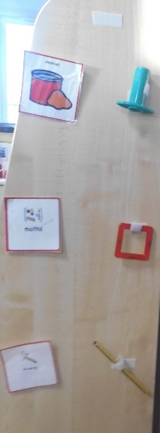
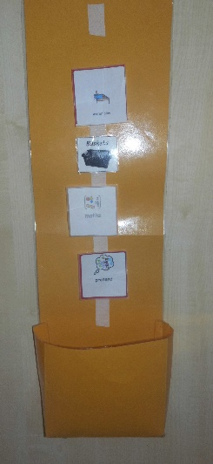
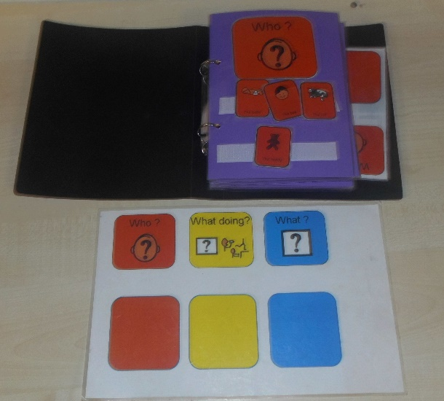
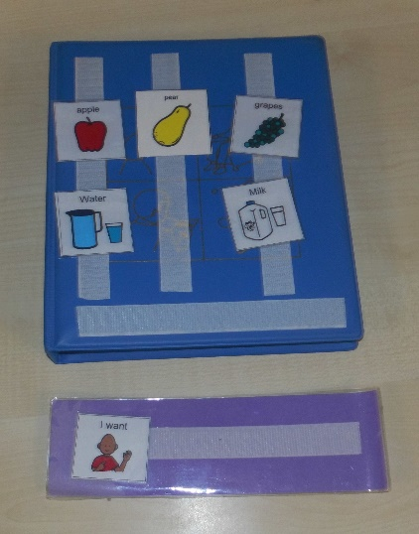

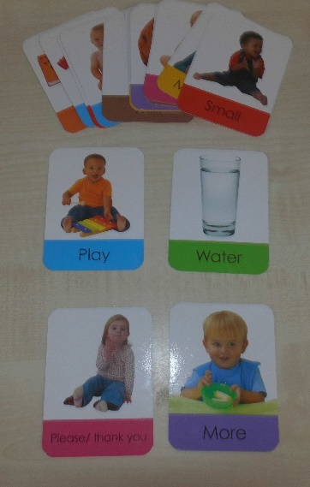
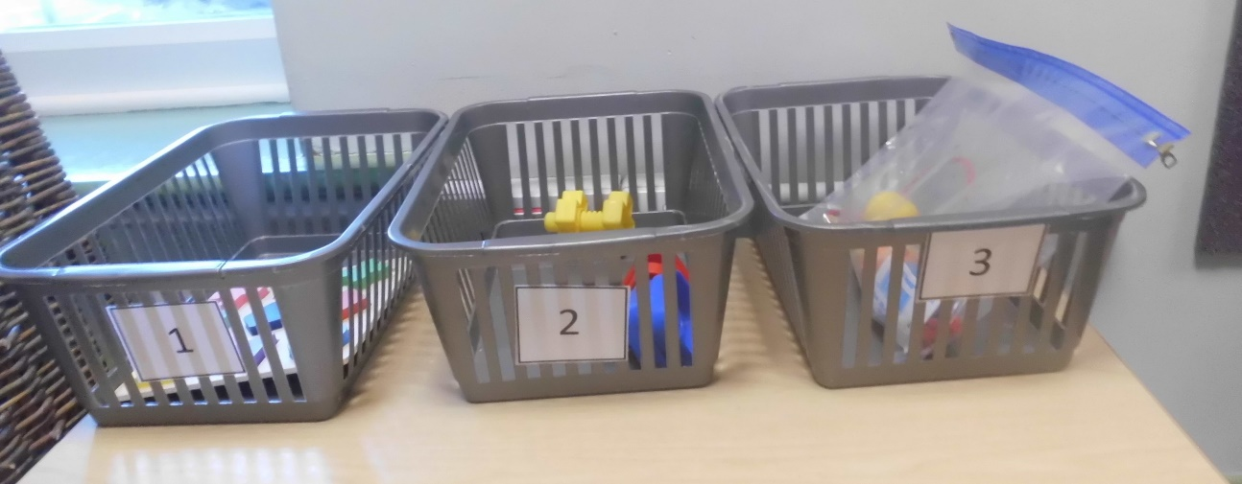

All of the additional strategies are planned, reviewed and discussed on a daily basis, at weekly SEND and Inclusion meetings and at Children’s Progress meetings.
All policies are written and reviewed with a commitment to promote equality of opportunity, including the interests of those with a disability or additional learning needs. All polices related to SEND and Inclusion are available to our website.

How does the school train staff and secure specialist expertise?
We offer a wide-range of training opportunities to ensure that our inclusive practice is of the highest quality. All staff have access to a range of continuing professional development opportunities through the School Development Plan, Appraisal and Supervision, their individual interests, fortnightly SEND meetings or working closely with outside professionals. We also arrange specialist training in relation to the needs of the children, for example stoma training, gastro feed training or tracheostomy training.
The SENDCO acts as a link to a wide range of other specialist agencies, such as Speech and Language Therapy, SEND Support Services, Educational Psychological Service, Child Development Centre, Physiotherapy and Occupational Therapy, Hearing and Visually Impaired Services, and parent advice groups. The SENDCO is kept up to date with local and national developments around SEND and attends specific training updates.

What specialist services and expertise are available at or accessed by the school?
The school’s SENDCO and the SEND team are well trained, experienced and knowledgeable professionals. St Edmund’s Nursery School has created a bespoke role within our organisation - Specialist Communication and Language practitioner – who is trained to deliver specific and individual support in the area of Speech, Language and Communication.
All additional support is closely monitored to ensure it has an ongoing positive impact on children’s progress.
We work closely with the Local Authority and outside agencies (see above) and value the input of their expertise putting into practice any advice given, for example a physio plan or visual and hearing impairment strategies.
St Edmund’s Nursery School works on Portage principles and holds Portage National Stamp of Approval.

What support do we have for you as a parent/ carer of a child with SEND?
We strive to promote positive reciprocal relationships between School and home to ensure that we are working in partnership and ensuring consistency, sharing strategies and support. The SENDCO is available to meet with you to discuss your child’s progress or any concerns/worries you may have. All information from outside professionals will be discussed and shared with you. The SENDCO will also arrange to meet with you to discuss any new assessments and ideas suggested by outside agencies for your child. We will always inform you about any additional support put in place for your child. We upload the videos of additional support being delivered on Famly so that you are able to see it and implement the same strategies at home. We organise regular coffee mornings/afternoons for families and staff to come together and share their experiences in a supportive and respectful environment. We often invite other professionals to those sessions such as an expert on Social, Communication and Autism, to offer an additional advice and support to families. We act as advocates for you and your child navigating the system and supporting you in finding the right school when your child is ready to move on to the next phase of their education.
Our Parental Involvement Workers offer a wide range of support. They organise sessions such as ‘Play and Learn’, ’50 Things to do Before You’re Five’ and exciting outings and trips to name just a few. St Edmund’s Nursery School employs staff from diverse cultures and backgrounds. In addition to English there are 12 different languages spoken by our team.

How will my child be included in activities outside the classroom including school trips?
We actively ensure that all our provision and additional experiences are accessed by all children. Our outings include trips within our community and wider areas of Bradford, weekly visits to local wetlands for Forest School experiences, trips to museums, Tropical World or the seaside. We also bring experiences to our Nursery such as weekly football sessions, weekly sessions with an in-house artist, annual visit from Mobile Farm or nocturnal animals. Risk assessments are carried out and procedures are put in place to enable all children to participate. For example we will organise appropriate transport that will accommodate any specialist equipment used by our children such as wheel chairs, walking frames or specialist chairs. We want all our children to participate in any outside school experiences and to enable this we will subsidise the cost of trips as necessary. Our Accessibility Plan is reviewed regularly.

How have we made sure St Edmund’s Nursery School is accessible to children with SEND?
As a school we are happy to discuss individual access requirements and have created a fully accessible site. Lift, evac chair. Each classroom is easily accessible for children and adults who use wheel chairs. Outdoors. Sensory Room. Each classroom uses visual labels and Makaton signs. We use visual aids and Objects of Reference in school to support learning. Children also have their own visual systems such as timetables or Picture Exchange Card Systems (PECS). We have a fully equipped Hygiene Suite with a hoist and adjustable bed to support the children with complex physical needs. Our rooms are audited by the Habilitation team, when needed, to ensure safe access for children with visual impairments. We have an Accessibility Plan on our website with up to date information as well as our plans for future adaptations. We are very reflective and responsive, so whatever changes need to be made for children to achieve and succeed will be made as soon as possible. We hold a ‘Physical Friendly Status’ which means that our building is accessible for children and adults with physical needs. (This is due for a renewal).

How do we support mental health and emotional well-being of our children?
For a number of years St Edmund’s Nursery School has been focusing on training staff on how to support children’s mental health and well-being. We now have well established co-regulation strategies in order to support children’s self-regulation skills. We help children acknowledge and name their emotions and feelings, we support them in recognising why are they are feeling this way and use strategies to guide them back towards a state off-balance. For example, when a child is crying because their mummy has gone, we would never say ‘It’s OK, you’re fine’. Instead we would say ‘I know you’re upset because your mummy has gone, I can see the tears rolling down your cheeks. Shall we go outside? That helped you yesterday and you love jumping on a trampoline.’ We adapt the language and strategies used according to the child’s level of understanding and the level of dysregulation. St Edmund’s Nursery School’s ‘Self-Regulation and Behaviour Policy and Guidelines’ is available on our website.
All our staff receive training on Co-Regulation and Self-Regulation to support children’s emotional well-being as well as training on how to support children who have endured Adverse Childhood Experiences (ACEs). We use Leuven’s scales to monitor children’s levels of well-being and involvement.

How will we support your child when they are transitioning to a Primary School or a different setting?
We recognise that moving on can be difficult for most children, but especially for those who have additional challenges. We help families to choose the right school for their children, providing information on what kind of provision is available in Bradford e.g. mainstream, special or resourced. When necessary, we will organise a supported visit to potential schools. We personalise our transition to ensure that these are as smooth as possible. If your child is moving to another school we will contact the school SENDCO and ensure they know about any special arrangements or support that needs to be put in place for your child. The SEND Team, whenever possible, will arrange additional visits to new schools for your child and personalised resources to support transition may be used. Staff from the receiving school are encouraged to visit us to see your child in their current setting. For those who need one, we will make sure that an EHCP is in place before children leave St Edmund’s and that all records are passed on as soon as possible to their next school.

Access to Additional Support for your child and family
There are many local and national organisations who can offer support and advice, including some charities and voluntary bodies.
A good place to start is the Bradford Parent Partnership, whose website can be found at http://www.barnardos.org.uk/parentpartnershipservice.htm (phone: 01274 481183).
- The SEND Team are available to help parents locate organisations that can offer more specialist advice. City of Bradford Metropolitan District Council Services: Switchboard: 01274 432111; www.bradford.gov.uk
- Disabled Children’s Information Service Produce a monthly newsletter for families who have a child with SEND. Contact: 01274 433861
- Support for parent carers in the Bradford District - https://www.carersresource.org/ Autism support - https://awareuk.org/ https://www.barnardos.org.uk/
- Bradford Actionaires for the blind and visually impaired - https://www.rnib.org.uk/ Bradford disabled sports - http://www.bradforddisabilitysports.co.uk/
- Family Centre Service Provide support and fun activities to help young children’s early learning and development; including activities for children with SEND and their families. For details of a centre in your area, contact the Families Information Service.
- Families Information Service (FIS) Information on childcare and short breaks, finance and benefits, health services, Portage, and local support groups for children with SEND. Contact: 01274 437503; 01274 431252 (Urdu, Punjabi); 01274 434905 (Eastern European).
- Local Offer Bradford The Local Offer provides web-based information on education, health and social care for families with a child aged from birth to 25 years who has SEND. www.localoffer:bradford.gov.uk
- Portage Service A home-visiting learning support and advice service for children with SEND (birth to 5 years). Contact: 01274 439500; www.portage.org.uk

How do we handle complaints at St Edmund’s Nursery School?
In the first instance, you should speak to your child’s key person, should you need to share any concerns with us. Most concerns are resolved readily and informally through discussion. However, if a resolution is not agreed upon, the matter may be escalated to the SENDCO and then the Executive Headteacher. A formal complaint needs to be put in writing, following our Complaints procedure within our Complaints Policy, which is available on the website. Beyond this, a complaint may be taken to the Governing Body or the Local Authority.

Contact details for any complaints, concerns or guidance
Sian Hudson, Executive Headteacher
sian.hudson@lilycroftnurseryschool.com

Ermina Kesedzic, Assistant Head/SENDCO
ermina.kesedzic@stedmundsbradford.org.uk

Telephone
01274 543 282

